Care Team Training 1.0

## 1.1 Ambulatory Services

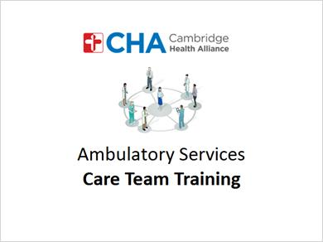

## 1.2 Welcome

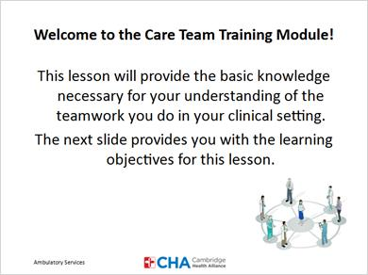

## 1.3 Learning Objectives

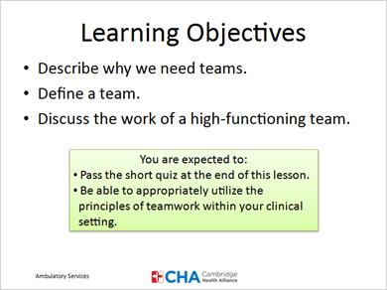

## 1.4 Where should you start?

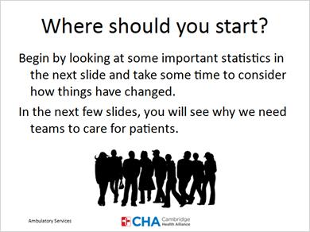

## 1.5 Causes of Death

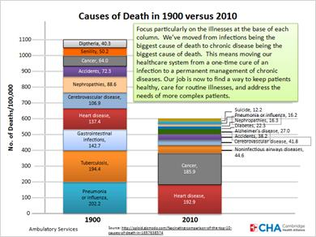

## 1.6 Value of Patient's Time

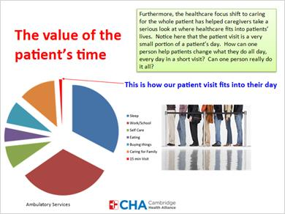

## 1.7 Why do we need a team?

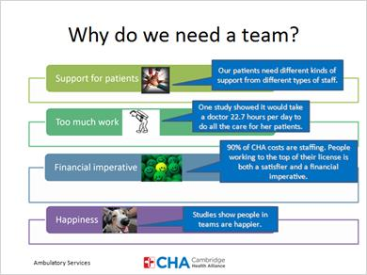

## 1.8 Quiz 1

*(Multiple Response; correct answers are checked)*

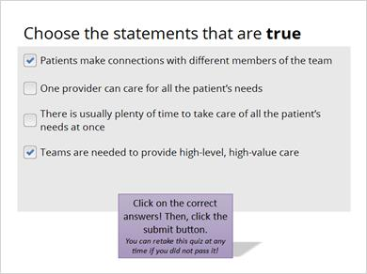

## 1.9 Redesigning Care Delivery

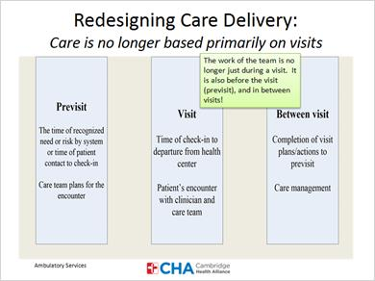

## 1.10 What is a Team?

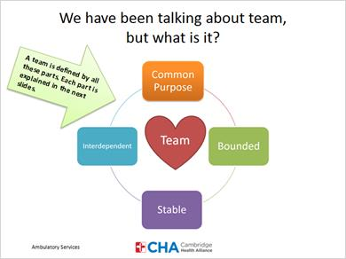

## 1.11 Team

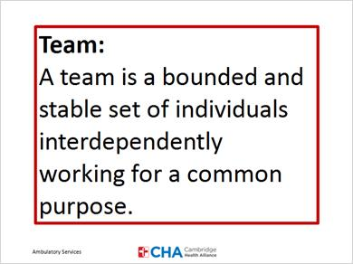

## 1.12 Common Purpose

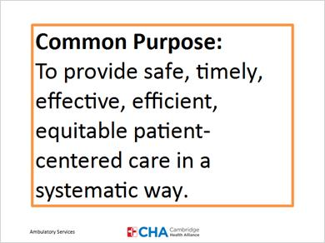

## 1.13 Bounded

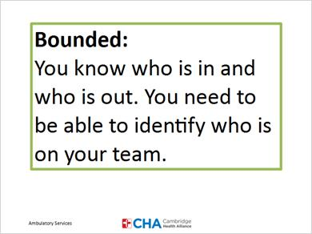

## 1.14 Stable

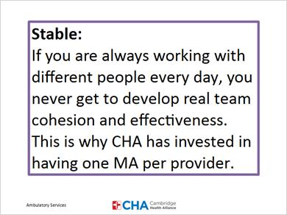

## 1.15 Interdependent

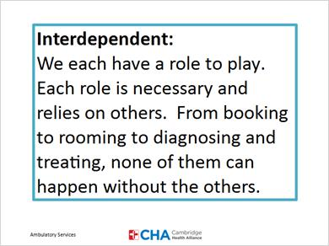

## 1.16 How Teams are built at CHA

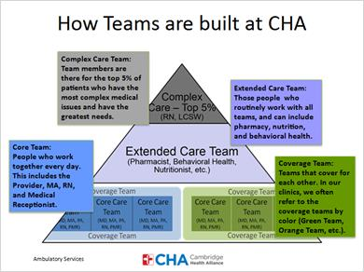

## 1.17 CHA Team

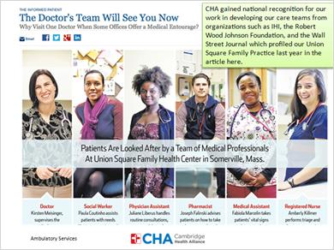

## 1.18 Quiz 2

*(Matching Drag-and-Drop; correct answers are shown in this slide)*

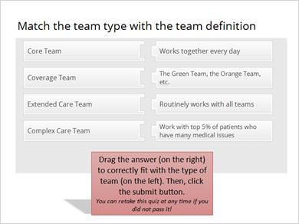

## 1.19 Let’s Do This!

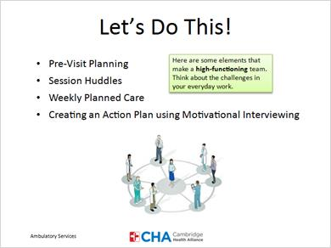

## 1.20 Traditional Methods

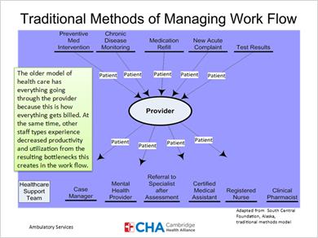

## 1.21 Parallel Work Flow Design

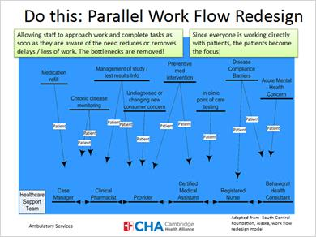

## 1.22 Process

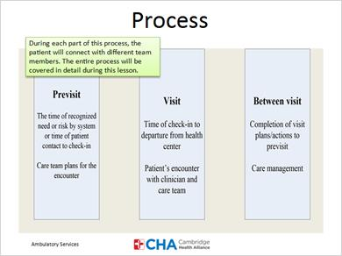

## 1.23 The Previsit

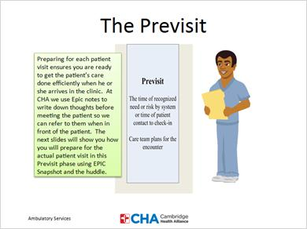

## 1.24 Primary Pre-visit Tasks

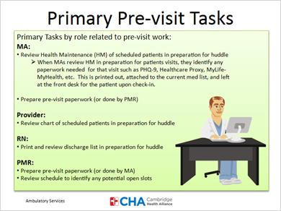

## 1.25 Snapshot

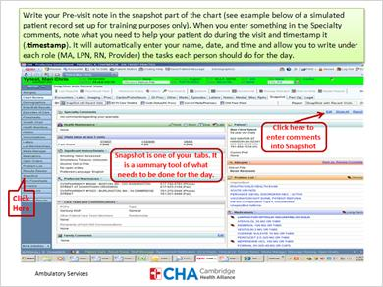

## 1.26 Discharge List

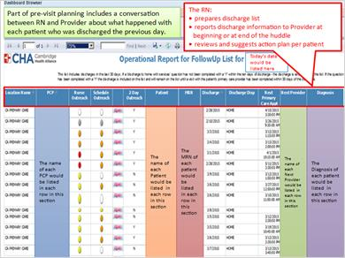

## 1.27 Quiz 3

*(Matching Drop-down; correct answers are shown)*

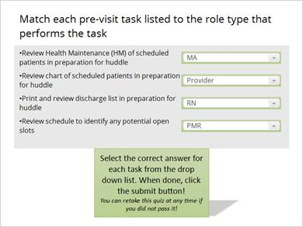

## 1.28 Huddles

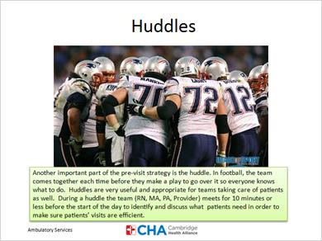

## 1.29 Perception of Team

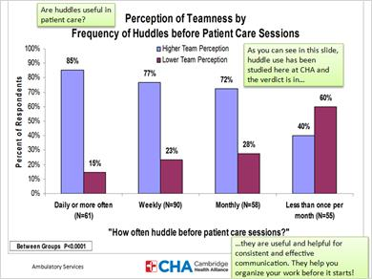

## 1.30 How to Conduct the Huddle

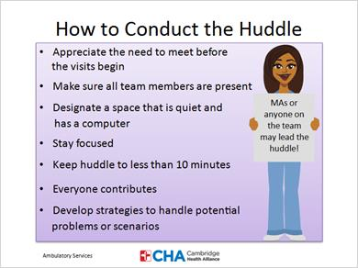

## 1.31 Quiz 4

*(Drag and Drop; correct answers are: quiet place with a computer, everyone prepared for the huddle, everyone contributes)*

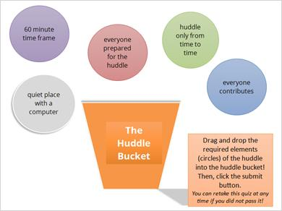

## 1.32 Meetings and Huddles

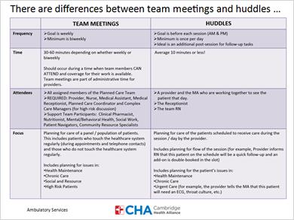

## 1.33 The Visit

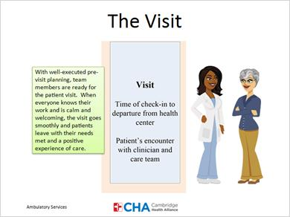

## 1.34 Rooming Guidelines

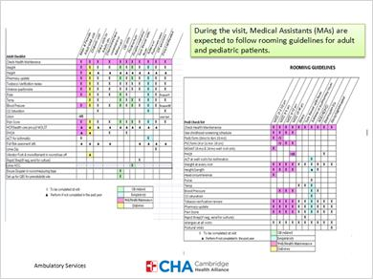

## 1.35 The Between Visit

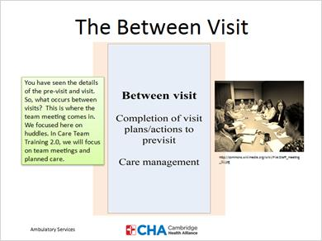

## 1.36 Your mission…

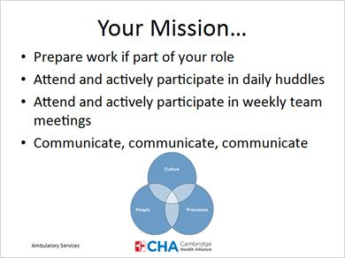

## 1.37 Next Steps

