Medical Assistant and Nursing Standing Orders

1.6 PPD placement
1.7 PPD reading (negative)
1.8 MA and Nurse standing order albuterol
1.9 MA standing order antipyretics
1.11 MA ordering labs
1.13 Urine Toxicity Screening
1.14 RN standing order to give Makena equivalent

1.6 TUBERCULIN SKIN TEST (TST)/PPD Placement

Subjective:
- Symptoms of TB (if patient is coughing, place mask on patient and yourself immediately):
  - Productive cough, chest pain, prolonged cough, fatigue, enlarged lymph nodes, hemoptysis (coughing up blood), night sweats, fever, chills, decreased appetite, or weight loss
- Screen patient for the following risks and document in chart if positive:
  - History of previously positive TST.
    - NOTE: A patient with a history of positive TST should NEVER receive another TST
    - Ask for documentation of one of the following w/in the last 2 years:
      - - Negative Chest Xray
      - - Negative Quantiferon blood test
      - - Complete course of antibiotic treatment
    - If the patient doesn’t have any of these forms of documentation available, consult with provider for follow up recommendations..
  - History of exposure to foreign visitors in the home from a high-risk country including Asia, Africa, Latin America, Eastern Europe, Russia.
  - HIV infected, immunosuppressed or before starting immunosuppressive therapy (e.g., chronic steroid use, TNF blockers**, chemotherapy)
  - Homeless
  - Staff member caring for high-risk populations (e.g., homeless shelters, drug/alcohol treatment facilities)
  - Health care worker (including volunteers) in facilities that care for patients at risk for TB
  - Inmate and staff of jails and prisons
  - Foster child, but only if no history is available of prior exposures to active TB
- The Tuberculin Skin Test (TST) is safe and reliable for pregnant women; no teratogenic effects have been documented.
  - Routine TST screening among pregnant women is not indicated, because pregnancy itself does not increase the risk for TB infection. However, be sure to test high risk pregnant women.
- Confirm patient can return to clinic within 48-72 hours for TST reading.

Objective:

Assess vital signs to make sure they are within normal limits

Assessment:

PPD-Tuberculosis Screening V74.1 Routine

Plan:

Order in Office Services: PPD 0.1 ml ID

The TST is performed by placing an intradermal injection of 0.1 ml of purified protein derivative (PPD) tuberculin containing 5 tuberculin units (TU) into the inner surface of the forearm. The injection should be made with a disposable tuberculin syringe, just below the surface of the skin, with the needle bevel facing upward. This should produce a discrete, pale elevation of the skin (a wheal) 6 mm to 10 mm in diameter. See TB Powerpoint.

In Nurse Documentation, double click on order, document where TST placed. Order should read “completed.”

See Quick Tips Sheet for help in documenting.

Make a MA appointment for patient to return to clinic for TST reading within 48-72 hours. Give patient reminder card.

Remember to code and concatenate document.

** TNF blockers target and neutralize tumor necrosis factor-alpha (TNF-α), a protein that, when overproduced in the body due to chronic inflammatory diseases, can cause inflammation and damage to bones, cartilage and tissue. The drugs in this class include Remicade (infliximab), Enbrel (etancercept), Humira (adalimumab), Cimzia (certolizumab pegol) and Simponi (golimumab). (FDA, 2009).

1.7 PPD Reading (Negative)
PPD may initially be read by a MA. If determined to be positive, MA should transfer visit to Nurse or Provider.

Requirements for Reading Results
- Test should have been placed 48-72 hours prior to reading.
- If patient no-shows:
  - positive test may still be read up to 1 week later
  - negative reaction read beyond 72 hours is not valid and needs to be repeated in 1-3 weeks
Subjective
- Symptoms of TB (if patient is coughing, place mask on patient and yourself immediately):
  - Productive cough, chest pain, prolonged cough (>3 weeks), fatigue, enlarged lymph nodes, hemoptysis (coughing up blood), night sweats, fever, chills, decreased appetite, or weight loss
- Screen patient for the following risks and document in chart if positive:
  - History of a previously positive PPD.
  - History of exposure to foreign visitors in the home from a high-risk country including Asia, Africa, Latin America, Eastern Europe, Russia.
  - HIV infected, immunosuppressed or before starting immunosuppressive therapy (e.g., chronic steroid use, TNF blockers**, chemotherapy)
  - Homeless
  - Staff member caring for high-risk populations (e.g., homeless shelters, drug/alcohol treatment facilities)
  - Health care worker (including volunteers) in facilities that care for patients at risk for TB
  - Inmate and staff of jails and prisons
  - Foster child, but only if no history is available of prior exposures to active TB
Objective
- Repeating vitals unnecessary if they were within normal limits at time of PPD placement.
- If outside of normal range at time of PPD placement, reassess vital signs.
Assessment
- Measure indurated (hard, swollen) area, across the forearm, see TB Slide Presentation found in the Resources File of Nursing Protocols. Test is considered positive if
  - ≥ 5mm and patient meets the criteria found below or from p. 8 in the Denver Health Latent TB Protocol.
  - ≥ 10mm see below.
  - ≥ 15mm for all other individuals, see below.
- Document
  - Open “View Results”, “Other Reports”. Click “Result Received” box and then add your interpretation of “see detail”. All results should be documented in mm, even negative ones. Examples are 0mm or 5mm.

See Quick Tips Sheet for help in documenting.
  - TB Powerpoint for more details.
Coding/Billing
- If pt is here for an INS physical, code and bill as usual.
- If pt is NOT here for an INS physical, code as usual and send task to Billing that this is a NO CHARGE visit.

Report any patient with symptoms and/or a positive PPD
to Nurse or Provider immediately

** TNF blockers target and neutralize tumor necrosis factor-alpha (TNF-α), a protein that, when overproduced in the body due to chronic inflammatory diseases, can cause inflammation and damage to bones, cartilage and tissue. The drugs in this class include Remicade (infliximab), Enbrel (etancercept), Humira (adalimumab), Cimzia (certolizumab pegol) and Simponi (golimumab). (FDA, 2009).

From Denver Health Community Health Services Protocol for Latent TB Infection (LTBI) Diagnosis and Management Pediatric and Adult Patients, from page 9 and on.
D. Classifying the TST return to top
Whether a reaction to the TST is classified as positive depends on the size of the induration and the person's medical and epidemiologic risk factors for TB. Patients who have a positive TST reaction should receive a clinical evaluation, including a chest x-ray, to rule out active TB disease. 5 or more millimeters of induration | 10 or more millimeters of induration
􀂃 Significant exposure to anyone with suspected or known TB  􀂃 Any individual being evaluated for disease consistent with tuberculosis  􀂃 Persons with x-ray evidence of old, healed TB (e.g., stable, fibrotic upper lobe infiltrates)  􀂃 Persons with behavioral risk factors for HIV infection who decline HIV testing, including persons of unknown HIV status who have a history of drug injection ‡  􀂃 Immunosuppressive conditions or patients currently taking or planning to take certain medications: ‡  􀂾 HIV-seropositive  􀂾 Congenital conditions causing immunosuppression  􀂾 Malignancies / cancers (e.g. cancer of the head and neck, lymphomas, leukemias)  􀂾 Individuals receiving the equivalent of > 15 mg/day of prednisone for at least one month. (Children receiving 0.5 mg/kg/day of prednisone)Individuals receiving inhaled steroids are not usually considered at increased risk unless unusually large doses are given  􀂾 Chemotherapy for cancer  􀂾 Tumor Necrosis Factor (TNF) blockers such as infliximab (Remicade), etanercept (Enbrel) for arthritis/Crohn’s disease  􀂾 Transplant patients (solid organ or bone marrow) on medications to prevent rejection  􀂾 Other medications such as methotrexate or cytoxan  􀂃 Those having an Immigration and Naturalization Service (INS) “change of status” exam | 􀂃 All children younger than 5 years old (i.e., up to the day of the fifth birthday)  􀂃 Persons who were born or lived in a country or area where TB incidence is high (e.g. Asia, Africa, Latin America, Eastern Europe, Russia or parts of Western Europe)  􀂃 Employees (including volunteers) or residents of congregate settings, such as hospitals, correctional facilities, homeless shelters, nursing homes, or drug treatment centers  􀂃 Employees or volunteers in health care facilities  􀂃 Persons with a history of drug injection or substance abuse (i.e., alcohol abuse or crack cocaine use) who are known to be HIV seronegative  􀂃 Persons with an increased risk of progression to TB disease (excluding HIV) such as: diabetes mellitus, silicosis, cancer of the head and neck, hematologic and reticuloendothelial disease (e.g., leukemia and Hodgkin's disease), end-stage renal disease, intestinal bypass or gastrectomy, chronic malabsorption syndromes, or low body weight (10% or more below ideal) ‡
‡ Common causes of anergy, the patient may have a negative or a smaller TST test despite having TB infection.
■ Do NOT place a TST if the individual has recently (within 6 wks) had a live virus vaccination (e.g. MMR, Varicella). It can result in a false-negative TST.
■ Low risk patients do not need screening. If a TST is placed, interpret as positive if > 15 mm induration.

1.8 MA and Nurse Standing Order Albuterol Treatment
To provide MAs and Nurses a standing order to administer Albuterol treatment to Clinica patients after receiving a verbal order from the provider.

After receiving a verbal order from a provider, medical assistants and nurses
may use this standing order to place order in EMR and administer albuterol treatment.

Treatment
- Make sure vitals are completed prior to administering albuterol.
  - Children age 2 years (≥15kg) to Adult
    - Albuterol 2.5mg/3ml single dose vials or “bullet”.
  - Children <2yrs and/or <15kg
    - Dose must be determined by provider.
- Order must be done in 2 places within the EMR.
  - First, order medication in Office Services, Misc. Drugs
  - Second, order nebulizer and 2nd pulse ox in Office Services, Misc. Drugs
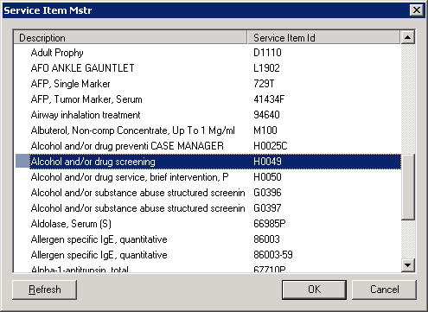

Order medication in Office Services, Misc. Drugs.
Assessments include:
- Wheezing, 786.07
- Shortness of Breath, 786.05
- Or ask provider
- Select Albuterol
- Enter Billing Diagnosis
- Enter “1” for dose
- Click Save

1

3
4
2

- Open the order and enter the Unit (, Exp Date, Lot Number, and Manufacturer.
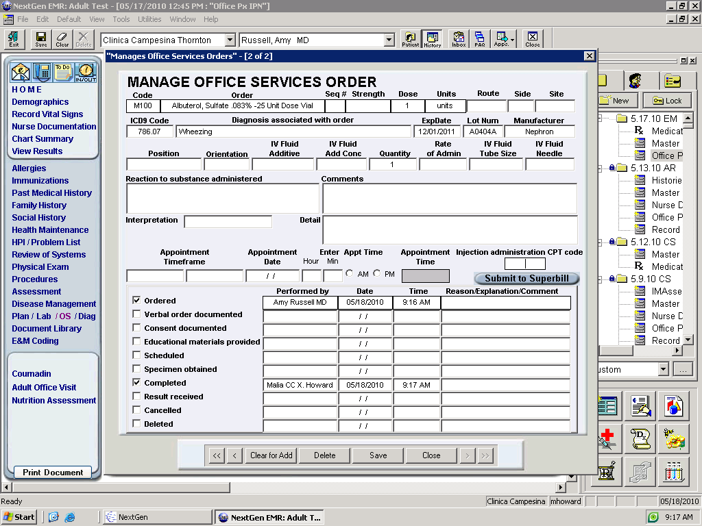
5

Albuterol, Non-comp Concentrate, Up To 1 Mg/m
8
6
7
Open the order:

- In Units select “units”
- Enter ExpDate
- Enter Lot Number
- Enter Manufacturer
- Click Completed
- Submit to Superbill
- Save

10

9

11

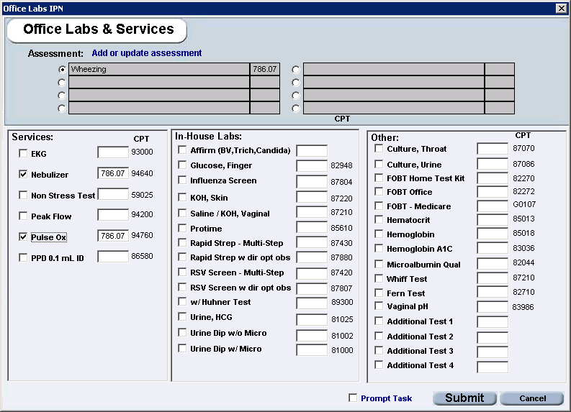
12
13
14
15

Order the Nebulizer and
2nd Pulse Ox in
Office Labs and Services:

- Enter the appropriate Assessment
- Click Nebulizer
- Click Pulse Ox
- Submit

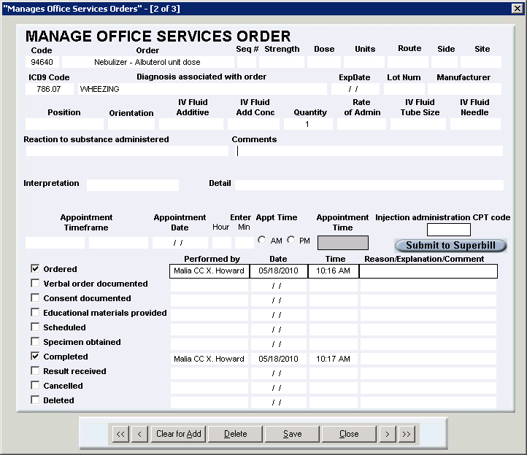
Open the Nebulizer Order

- Click Completed
- Submit to Superbill
- Save

18
17
16

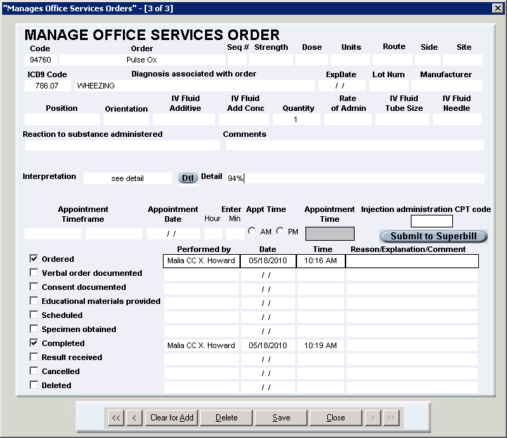
19
21
23
22
Order the Nebulizer and
2nd Pulse Ox in
Office Labs and Services:

- In Interpretation select
“see detail”
- In Detail enter pulse ox result
- Click Completed
- Submit to Superbill
- Save

20

References

Uptodate. (2009). Retrieved 1/25/10 from http://www.uptodate.com/online/content/topic.do?topicKey=drug_a_k/128401&selectedTitle=1%7E150&source=search_result#F181461

Epocrates. (2010). As retrieved 3/8/10.

Nephron Pharmaceutical Corporation Drug Information for Albuterol Sulfate Inhalation solution 0.083%.

1.9 MA Standing Order Antipyretics/Pain Reliever
To provide MAs a standing order to dispense acetaminophen and/or ibuprofen to Clinica patients after receiving a verbal order from the provider. Nurses: please see Nurse Standing Order for Antipyretics and Pain Relievers.

After receiving a verbal order from a provider, medical assistants may use this standing order to determine acetaminophen or ibuprofen dosage, place order in EMR, and dispense to patient.

Treatment
- Confirm/document medication allergies.
- Determine time of last dose of Tylenol/Motrin. Do not give if most recent dose was within last 4hrs.
- Infants and Children
  - See Tylenol/Motrin dosing schedule for Infants and Children see below or here.
    - Do not exceed 5 doses/24hrs.
    - Use weight, not age, when determining dose amount.
- Adults
  - Acetaminophen: 325-1000 mg PO Q4-6 hours according to dosing schedule. Max 1g/dose. Do not exceed 4g/24hrs.
  - Ibuprofen:
    - 200-400 mg/dose PO Q4-6 hours, max 1200mg/day for fever.
    - 400mg/dose PO Q4-6 hours, max 2400mg/day for mild to moderate pain.
    - Do not give to pregnant women or patients taking warfarin (Coumadin).
- Order in Office Services, Misc. Drugs.
- Enter dose and units you will actually be administering of the medication.
- Assessments include:
  - Fever, unspecified 780.60
- When prompted to task, can click “cancel.”

Ibuprofen example:
Please note, Infant dose is not the same as Pediatric dose!
See dosing schedule when entering dose!

- Open the order and enter the Route, Exp Date, Lot Number, and Manufacturer.

- Make sure to put any drug allergies or NKDA in comments section!
- Check mark Verbal order documented and Completed once medication has been given. Submit to Superbill.

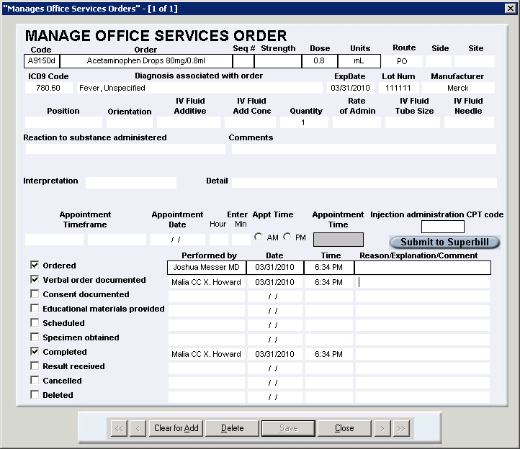

NKDA, last dose of Tylenol at 12pm

ACETAMINOPHEN
(Tylenol)
For Children and Infants
(for pain or fever)

Age/Weight | Suspension/Liquid  (160 mg/5 mL) | Chewable Tablets  (80 mg/tablet) | Junior Strength  (160 mg/tablet)
0-3 months (6-11 pounds) | ¼ teaspoon (1.25 mL)
4-11 months (12-17 pounds) | ½ teaspoon (2.5 mL)
12-23 months (18-23 pounds) | ¾ teaspoon (3.75 mL) | 1 ½ tablets
2-3 years (24-35 pounds) | 1 teaspoon (5 mL) | 2 tablets
4-5 years (36-47 pounds) | 1 ½ teaspoon (7.5 mL) | 3 tablets
6-8 years (48-59 pounds) | 2 teaspoons (10 mL) | 4 tablets | 2 tablets
9-10 years (60-71 pounds) | 2 ½ teaspoons (12.5 mL) | 5 tablets | 2 ½ tablets
11 years (72-95 pounds) | 3 teaspoons (15 mL) | 6 tablets | 3 tablets
12-14 years (96 + pounds) |  |  | 4 tablets
Give child acetaminophen every 4 hours if needed. Do not give child more than 5 doses in 24 hours.

Your child’s dose:________________ Your child’s weight: ________________

IBUPROFEN
(Advil, Motrin)
For Children and Infants 6 months and older
(for pain or fever)

Age/Weight | Drops  50 mg per 1.25 mL  (dropperful) |  | Liquid/Oral Suspension  100 mg/5 mL |  | Chewable Tablets
 | Fever less than 102.5°F | Fever 102.5°F or more | Fever less than 102.5°F | Fever 102.5°F or more | Children’s  (50 mg/tablet) | Junior  (100 mg/tablet)
6-11 months  (12-17 pounds) | ½ dropper  (0.6 mL) | 1 dropper (1.25 mL) | ¼ teaspoon  (1.25 mL) | ½ teaspoon  (2.5 mL)
12-23 months  (18-23 pounds) | 1 dropper  (1.25 mL) | 2 droppers (2.50 mL) | ½ teaspoon  (2.5 mL) | 1 teaspoon  (5 mL)
2-3 years  (24-35 pounds) | 1 ½ dropper (1.85 mL) | 3 droppers  (3.75 mL) | ¾ teaspoon  (3.75 mL) | 1 ½ teaspoons  (7.5 mL)
4-5 years  (36-47 pounds) |  |  | 1 teaspoon  (5 mL) | 2 teaspoons  (10 mL) | 3 tablets | 1 ½ tablets
6-8 years  (48-59 pounds) |  |  | 1 ¼ teaspoon  (6.25 mL) | 2 ½ teaspoons  (12.5mL) | 4 tablets | 2 tablets
9-10 years  (60-71 pounds) |  |  | 1 ½ teaspoons  (7.5 mL) | 3 teaspoons  (15 mL) | 5 tablets | 2 ½ tablets
11-12 years  (72-95 pounds) |  |  | 2 teaspoons  (10 mL) | 4 teaspoons  (20 mL) | 6 tablets | 3 tablets
Don’t give to child if he/she is allergic to aspirin.
Give to child every 6-8 hours as needed. Don’t give to child more than 4 times in 24 hours.

Your child’s dose:________________ Your child’s weight: ________________

ACETAMINOPHEN
(Tylenol)
Para Los Niños y Enfantes
(para dolor o fiebre)

Edad/Peso | Suspension/Liquido  (160 mg/5 mL) | Chewable Tablets (Tabletas para masticar)  (80 mg/tableta) | Junior Strength  (160 mg/tableta)
0-3 meses (6-11 libras) | ¼ cucharadita (1.25 mL)
4-11 meses (12-17 libras) | ½ cucharadita (2.5 mL)
12-23 meses (18-23 libras) | ¾ cucharadita (3.75 mL) | 1 ½ tabletas
2-3 años (24-35 libras) | 1 cucharadita (5 mL) | 2 tabletas
4-5 años (36-47 libras) | 1 ½ cucharadita (7.5 mL) | 3 tabletas
6-8 años (48-59 libras) | 2 cucharaditas (10 mL) | 4 tabletas | 2 tabletas
9-10 años (60-71 libras) | 2 ½ cucharaditas (12.5 mL) | 5 tabletas | 2 ½ tabletas
11 años (72-95 libras) | 3 cucharaditas (15 mL) | 6 tabletas | 3 tabletas
12-14 años (96 + libras) |  |  | 4 tabletas
De a su niño acetaminophen cada 4 horas si necesita. No de su niño la medicina más de 5 veces en 24 horas.

La dosis para su nino/a:________________ El peso de su nino/a: ________________

IBUPROFEN
(Advil, Motrin)
Para Los Niños y Enfantes de 6 meses o mayor
(para dolor o fiebre)

Edad/Peso | Drops (Gotas)  50 mg per 1.25 mL  (gotero) |  | Liquid/Oral Suspension  (Liquido)  100 mg/5 mL |  | Chewable Tablets  (Tabletas para masticar)
 | Fiebre menos de 102.5°F | Fiebre 102.5°F  o más | Fiebre menos de 102.5°F | Fiebre  102.5°F  o más | Children’s  (50 mg/tablet) | Junior  (100 mg/tablet)
6-11 meses  (12-17 libras) | ½ gotero  (0.6 mL) | 1 gotero  (1.25 mL) | ¼ cucharadita  (1.25 mL) | ½ cucharadita  (2.5 mL)
12-23 meses  (18-23 libras) | 1 gotero  (1.25 mL) | 2 goteros  (2.50 mL) | ½ cucharadita  (2.5 mL) | 1 cucharadita  (5 mL)
2-3 años  (24-35 libras) | 1 ½ gotero (1.85 mL) | 3 goteros  (3.75 mL) | ¾ cucharadita  (3.75 mL) | 1 ½ cucharadita  (7.5 mL)
4-5 años  (36-47 libras) |  |  | 1 cucharadita  (5 mL) | 2 cucharaditas  (10 mL) | 3 tabletas | 1 ½ tabletas
6-8 años  (48-59 libras) |  |  | 1 ¼ cucharadita  (6.25 mL) | 2 ½ cucharaditas  (12.5 mL) | 4 tabletas | 2 tabletas
9-10 años  (60-71 libras) |  |  | 1 ½ cucharadita  (7.5 mL) | 3 cucharaditas  (15 mL) | 5 tabletas | 2 ½ tabletas
11-12 años  (72-95 libras) |  |  | 2 teaspoons  (10 mL) | 4 cucharaditas  (20 mL) | 6 tabletas | 3 tabletas
No de al niño si el/ella tiene alergia a Aspirina.
De al niño cada 6 a 8 horas. No de más que 4 veces en 24 horas.

La dosis para su nino/a:________________ El peso de su nino/a: ______

MAs writing lab orders in NextGen (NG)
Last revised: Friday August 5, 2011
Authors: Ed Farrell, Chris Keenan
Reviewed by other CMDs, Clinical IT, Lana Barnes

Background:
- Decrease lab ordering errors
- Decrease number of requisitions from Quest requesting correct diagnosis code.
- Increase standardization
- Enable MAs to have more streamlined control over the lab ordering process

Processes:
  - Provider adds Assessments in encounter and writes labs needed in the plan under each assessment. The ICD-9 code is then easily associated with each assessment.
- Provider alerts MA that patient needs labs by one of the methods below:
    - Verbally
    - Using black flag
    - Sending MA task
  - MA looks for assessments/labs needed in the plan and orders in NG
  - Provider can verify correct labs ordered when completing note/encounter.

Exceptions and Caveats:
- Providers themselves must order unusual labs within NG (or tell the MA exactly what to order) to ensure the correct lab is ordered.
- Providers must specify exact type of test. For example, when ordering TSH, must write which one of the 4 tests is being ordered.
- If additional labs are needed after requisition has been sent, the provider immediately tasks the MA or MA group. The task should be completed within 24 hours.
- Providers should jump in and help MA teammate if requested/needed.

Standing Order for Labs (except as noted below, MA can order without confirming with clinician):
Reason for visit | Test (Quest ID, if applicable) | ICD-9  codes | Comments
Diabetes | Hgb A_{1c}  lipid panel (9689T)  urine microalbumin (6517X) | 250.xx | Hgb A_{1c}: ≥4× per year  lipids and urine: ≥1× per year
 | CMP (10231X) | V58.69 | if pt taking statin and ≥1 year since last CMP
Preventive Medicine | Pap | V72.31
 | GC/CT (17305X) | V74.5 | age ≤24 yrs, or ≥25 yrs with a history of chlamydial or other STI, new or multiple sexual partners
 | Pap | V76.2 | if not done as part of Well Woman exam
Acute: dysuria or frequent urination | UA  urine for C& S (6304R) | 788.1
Acute: sore throat | throat culture (6262E) | 462 | Get swab but confirm with clinician before submitting/billing
OB Prenatal - Initial | prenatal profile (182A)  GC/CT (17305X)  HIV (19728X)  urine for C&S (6304R) | V22.x,  V23.x | if EGA≥8 wks (if known based on LMP or US)
OB Prenatal | urine for C& S (6304R) | V22.x,  V23.x | @ EGA 12-16 wks if not done earlier
OB Prenatal | 1-hr glucose (104497W)  Hct (45443E) | V22.x,  V23.x | @ EGA 24-28 wks
OB Prenatal | antibody screen, RBC (2782A  or 8904R) | V22.x,  V23.x | @ EGA 24-28 wks in unsensitized Rh (D)-negative women
OB Prenatal | vaginal/anal GBS (5827W) | V22.x,  V23.x | @ EGA 35-37 wks
Acute or Office: missed period | urine hCG | 626.0,  V72.40
Acute: abdominal pain | UA, urine hCG | 789.0x | Women of childbearing age (age ≥12 yrs, or ask if periods have started)
Any | HIV (19728X) | V73.89 | If pt requests
Any | PT with INR (26F) | V58.61 | If pt taking warfarin (Coumadin®) and ≥4 wks since last PT
Well child | Hct | V78.0 | @ age 15 mos (if not already done @ WIC office); ≥1× between ages 18 and 72 mos if not done previously
 | Lead (56713E) | V82.5 | @ age 15 mos; ≥1× between ages 18 and 72 mos
 | Newborn Screen #2 (7034-5) | V77.3 | best done @ age 3-30 dys
Abbreviations: CMP=comprehensive metabolic panel; CT=Chlamydia trachomatis; C&S=culture and sensitivities; EGA=estimated gestational age; GAS=group A strep; GBS=group B streptococcus; GC=Neisseria gonorrhoeae; Hct=Hematocrit; Hgb=hemoglobin; INR=international normalized ratio; LMP=(date of 1st day of) last menstrual period; pt=patient; PT=prothrombin time; STI=sexually transmitted infection; US=ultrasound; ≥=at least; ≤=not more than; ×=time(s)

Highlighted tests are usually done in-house, MA and provider teamlet can decide this.
Ultimately, provider needs to decide on diagnosis. At this moment, we only need to have profound OCD about this when patient has Medicare.

Sec 1.13 In-House Urine Drug Screening

Subjective:
- Check that the provider has ordered the in-house urine drug screen for the patient.

Objective:

Vital signs (consult provider if outside of normal limits)

Order Office Services: CPT code=80101, Drug Screen, Qualitative, Single Class

Assessment:

Therapeutic Drug Monitoring ICD-9: V58.83

Perform Test:

Place 3 drops of urine in each sample well on the multi-CLIN card

Wait 5 minutes

Interpret Results

Confirm validity by reviewing negative & positive control lines

There MUST be a line in the Negative Control region for the result to be valid

There must NOT be a line in the Positive Control region for the result to be valid

See Image 3 below:

Notes:

The shade of the colored line in the test region may vary. The result should be considered negative when there is even a faint color line.

If a colored line appears in the negative control region, no line appears in the positive control region and no line appears in the test region next to the name of a certain drug tested it is a presumed positive. Any disputed results may be sent to Quest for confirmatory testing based on provider discretion.

If no line appears in the negative control region and/or a line appears in the positive control region inadequate sample volume or incorrect procedural techniques are the most likely reasons for an invalid result. Review directions & repeat the test with a new test card.

Examples:

Plan/Education:
- Advise patient that the provider will review the results and the patient will be contacted if necessary.
- DO NOT COMMUNICATE THE RESULTS DIRECTLY TO THE PATIENT WITHOUT FIRST REVIEWING WITH PROVIDER!

Eligible Patients:
- Patients on Drug Contracts:
  - Generally at the beginning of the contract
  - Annually after that or per provider request
- Patients in Pain Management Groups
  - Done per Provider instructions
- Other patients as directed by Provider

Limitations
- The multi-CLIN Drug Screen Test Device provides only a qualitative, preliminary analytical result. A secondary analytical method could be used if a confirmed result is necessary. Gas chromatography/mass spectrometry (GC/MS) is the preferred confirmatory method.
- There is a possibility that clinical technical or procedural errors, as well as other interfering substances in the urine sample may cause erroneous results.
- Adulterants, such as bleach and/or alum, in urine samples may produce erroneous results regardless of the analytical method used. If adulteration is suspected, the test should be repeated with another urine sample.
- A preliminary positive result does not indicate level of intoxication, administration route or concentration in urine.
- A negative result may not necessarily indicate drug-free urine. Negative results can be obtained when drug is present but below the cut-off level of the test.
- Test does not distinguish between drugs of abuse and certain medications.
- A preliminary positive test result might be obtained from certain foods or food supplements.

Consult provider immediately if:

Patient has questions about the test that you are unable to answer.

back to top of protocol

In-House Urine Drug Screening
Cheat Sheet (post in lab for quick reference):

Place 3 drops of urine in each sample well on the multi-CLIN card

Wait 5 minutes

Confirm validity by reviewing negative & positive control lines

There MUST be a line in the Negative Control region for the result to be valid

There must NOT be a line in the Positive Control region for the result to be valid

1.14 RN Standing Order to give MAKENA EQUIVALENT

(Hydroxyprogesterone Caproate)

To provide Nurses a standing order to give Makena equivalent to Clinica’s pregnant patients at risk of preterm labor after receiving a written order from the provider. (in conjunction with CLIN 367 Hydroxyprogesterone caproate administration)

Overview
- Confirm/document medication allergies. Confirm patient does not have allergy to sesame.
- Confirm order for Makena in NextGen Medication Module
- Stop date should coincide with patient’s 34-37th week of pregnancy
- The vial is compounded in a 250mg/ml dose and comes in a 4ml vial, enough for 4 doses. Label the bottle with a patient label as this will become that patient’s vial.
- Once you have given the 3rd dose, notify COM that another vial needs to be reordered for that particular patient
- The vial is good for 28 days.
- If the patient doesn’t need exactly 4 doses of therapy, the remainder can be used for another patient.

Administration
- Administer 1 ml or 250mg each week.
- Clean top of vial with an alcohol swab
- Use 18 gauge needle to draw needle to draw up 1 ml medication
- Discard draw needle
- Place 1 ½ inch, 20 gauge needle onto syringe
- Administer to patient through the ventrogluteal injection site.
- Document lot number and expiration date in the HPI.
- Have patient wait 15 minutes to ensure no adverse reaction.
  - Once patient has received three injections with no adverse reaction, patient no longer has to wait 15 minutes after receiving the injection.
- Schedule patient or have patient schedule follow-up visit for the following week, same day.
- Store patient labeled Makena in the medication cabinet until next appointment

